**IOT based Health Care Monitor System**

*A Project report submitted in partial fulfilment of the requirements for the award of the Degree of*

**BACHELOR OF TECHNOLOGY**

**IN**

**COMPUTER SCIENCE AND SYSTEMS ENGINEERING**

Submitted by

**Elisha Maria K N M O 318114110009**

**Gubbala. Teja sree 318114110010**

**Gudla. Yamini 318114110012**

Under the esteemed guidance of

Dr. B Esther Sunanda

Assistant Professor (C)

Andhra University



**DEPARTMENT OF COMPUTER SCIENCE AND SYSTEMS ENGINEERING**

**ANDHRA UNIVERSITY COLLEGE OF ENGINEERING FOR WOMEN Visakhapatnam-530017**

YEAR OF SUBMISSION: 2022

**CERTIFICATE**

**ANDHRA UNIVERSITY COLLEGE OF ENGINEERING FOR WOMEN**

**VISAKHAPATNAM**



This is to certify that the main project entitled ―**IOT based Health Care Monitor System** is the bonafide work done by **Elisha Maria K N M O (318114110009), Gubbala Teja sree(318114110010), and Gudla Yamini (318114110012**), submitted in the partial fulfilment of the requirement for the award of the Degree of Bachelor of Technology in Computer Science and Systems Engineering during **April 2022- May 2022**.

**Signature of Project Guide Signature of Head of the Department**

**Dr. B Esther Sunanda Prof. B. PRAJNA**

Assistant Professor (C) Head of the Dept.

Department of CS&SE Department of CS&SE

**ACKNOWLEDGEMENT**

We take this opportunity to express deep gratitude to the people who have been instrumental in the successful completion of the project.

We would like to thank our project guide **Dr. B Esther Sunanda**, Assistant Professor, Department of Computer Science and Systems Engineering, for the continuous supervision and support, which was greatly helpful in the progression and smoothness of the entire project work.

We would like to thank **Prof. B. Prajna**, Head of the Department, Computer Science and Systems Engineering, for the encouragement in the aspect of our course and gave us official support for the progress of our project. We express our sincere thanks to our beloved Principal, **Prof. S. K. Bhatti**for giving us the opportunity to carry out the project work successfully.

We would also like to extend our gratitude to Lab Technicians and our sincere gratitude towards all the faculty members and Non-Teaching Staff in the Department of Computer Science and Systems Engineering for supporting us. We would also like to thank our parents and friends, who have willingly helped us out with their abilities in completing the project work.

With gratitude,

**Elisha Maria K N M O (318114110009)**

**Gubbala Teja sree (318114110010)**

**Gudla Yamini (318114110012)**

**DECLARATION**

We hereby declare that the project work entitled ― **IoT Based Health Monitor System**, is a bonafide work done by us, under the esteemed guidance of **Dr. B Esther Sunanda**, Assistant Professor, Department of CS&SE, **Andhra University College of Engineering for Women**. This project report is being submitted in the partial fulfilment of the requirements for the award of Degree of Bachelor of Technology in Computer Science and Systems Engineering during the academic year 2021- 2022. This project possesses originality as it is not extracted from any source and it has not been submitted to any other institution or university.

NAME REGD. NO SIGNATURE

**Elisha Maria K N M O 318114110009**

**Gubbala Teja sree 318114110010**

**Gudla Yamini 318114110012**

Visakhapatnam

Date:

**ABSTRACT**

Healthcare is given extreme importance nowadays by each country with the advent of the novel coronavirus. Internet of Things (IoT) is the new revolution of the internet which is a growing research area especially in health care. With the increase in use of wearable sensors and smartphones, remote healthcare monitoring has evolved at such a pace. IoT monitoring of health helps in preventing the spread of disease as well as to get a proper diagnosis of the state of health, even if the doctor is at a far distance.

The main objective of this project is to demonstrate the versatility of applying IoT based devices in the health care sector for the improvement of better treatments. This project is designed to develop and implement a novel IoT-based smart health monitoring system which can display and measure human body temperature, oxygen saturation level, and pulse rate through a mobile application, which has been developed so that the patient can seek medical attention even if the specialist is physically unavailable. Not just general health but also mental health patients can be monitored for proper diagnosis by their doctors using measured values of the patient’s heart rate.

**INDEX**

| **S.No.** | **Contents** | **Page Number** |
| --- | --- | --- |
| 1. | Introduction  1.1. History of IoT  1.2. Preview of the Project  1.3. Objective of the Project  1.4. Scope of the Project  1.5. Purpose of the Project | **1**  1  7  8  9  9 |
| 2. | Review of literature | **11** |
| 3. | Description of the IoT model  3.1 Connection between Health Care Sector and Technology  3.2 Module Functionality  3.2.1 Pulse Oxygen Sensor  3.2.2 Room temperature and Humidity Sensor  3.2.3 Body Temperature Sensor  3.2.4 Saline Detector  3.3 IOT and Model applications | **14**  14  15  15  15  15  16  16 |
| 4. | Requirement Specification  4.1. Hardware Requirements  4.2. Software Requirements | **18**  18  30 |
| 5. | Procedure  5.1 Detailed Procedure  5.2 System Analysis  5.3 Design  5.3.1 Block Diagram  5.3.2 Flow Chart  5.3.3 Circuit Diagram | **32**  32  32  33  33  34  35 |
| 6. | Coding | **36** |
| 7. | Case Studies  7.1. Case study 1: Proper Monitoring of Patients admitted in the  hospital  7.2. Case study 2: Monitoring of old age bed ridden patients | **42**  42  42 |
| 8. | Test Cases | **43** |
| 9. | Experimental Results | **46** |
| 10. | Conclusion and Future Scope | **47** |
|  | Bibliography  Appendix  Research Paper and Certificates | **48**  **49**  **50** |

**LIST OF FIGURES**

|  |  |  |
| --- | --- | --- |
| **Figure No** | **Figure Name** | **Page No** |
| Fig. a | ESP8266 board | **18** |
| Fig**.** b | ESP8266 Pin Diagram | **19** |
| Fig. c | Arduino Uno Board | **20** |
| Fig. d | Arduino Pin Diagram | **21** |
| Fig. e | MAX30100 | **22** |
| Fig. f | MAX30100 Pin Diagram | **22** |
| Fig. g | LM35 Body Temperature | **23** |
| Fig. h | LM35 pin Diagram | **24** |
| Fig. i | DHT11 Sensor | **25** |
| Fig. j | DHT11 Pin Diagram | **26** |
| Fig. k | LM358 Comparator | **27** |
| Fig. l | Breadboard | **28** |
| Fig. m | Jumper Wires | **28** |
| Fig. n | Buzzer | **28** |
| Fig. o | Project Block Diagram | **33** |
| Fig. p | Project Flow Chart | **34** |
| Fig. q | Project Circuit Diagram | **35** |
| Table. 1 | Minimum value test case | **43** |
| Table. 2 | Moderate value test case | **44** |
| Table. 3 | Maximum value test case | **44** |
| Table. 4 | Experimental results | **46** |
| Fig. r | Output in Blynk | **46** |

**1.INTRODUCTION**

The project's history, preview, objective, scope, and purpose are all included in this section. The history of the project talks about the origin of IOT. Project preview is about the main intention behind developing this model. Objective of this project is to make health monitoring of a patient much more reliable and portable. The main purpose in designing this project is to improve the demand and usage of technology in the health care sector.

**1.1 History of IoT:**

The term "internet of things" has been around for 20 years. However, the concept of connected gadgets had been known for a long time, at least since the 1970s. The concept was dubbed "embedded internet" or "pervasive computing" at the time. Kevin Ashton, who worked for Procter & Gamble at the time, created the term "Internet of Things" in 1999. In order to promote RFID, Ashton, who worked in supply chain optimization, wanted to draw top management's attention to a new intriguing technology called RFID. IoT was created because the internet was the biggest new technology in 1999, and it made sense to him, so he dubbed his presentation "Internet of Things."Despite Kevin's ability to pique the curiosity of some P&G executives, the name "Internet of Things" did not catch on. The Internet of Things was a common topic used by the media at the beginning of the 21st Century with several major developments paving the way for the future of IoT. LG Electronics introduced the world’s first refrigerator connected to the internet in 2000. Allowing consumers to do their food shopping online and make video calls. This invention was followed by a small rabbit-shaped robot in 2005 that could report the latest news, weather forecasts and stock market changes. While the first International Conference on Internet of Things was held in 2008 in Switzerland. Today there are more than 27 billion devices connected to the Internet of Things, with experts expecting this number to rise to over 100 billion devices by 2030. The internet of things (IoT) has only recently become ingrained in our everyday life. It surrounds us everywhere we go: connected cars driving on the street, home automation devices located in the house, smart office sensors powering digital, and fitness trackers worn on our bodies. Altogether, they create a massive ecosystem of 26.66 billion interconnected things, according to Statista, which hold a remarkable influence over societies and economies worldwide.

**1.1.1 The definition of IoT**

The Internet of Things (IoT) is defined as a network of interconnected devices. The term "internet of things" refers to anything that is connected to the internet, but it is increasingly being used to describe objects that are connected to the internet ""Talk" to one another. Simply said, the Internet of Things is a network of linked devices ranging from simple sensors to smartphones and wearables. It is feasible to "collect information, analyze it, and develop an action" to assist someone with a specific activity or learn from a process by merging these linked devices with automated systems.

"It's about networks, devices, and data”. IoT allows objects connected to a closed private internet connection to communicate with one another and share information "The Internet of Things connects these disparate networks. It allows devices to communicate not just inside close silos, but also across other networking kinds. An IoT ecosystem consists of web-enabled smart devices that use embedded systems, such as processors, sensors and communication hardware, to collect, send and act on data they acquire from their environments. [IoT devices](https://internetofthingsagenda.techtarget.com/definition/IoT-device) share the sensor data they collect by connecting to an IoT gateway or other edge device where data is either sent to the cloud to be analyzed or analyzed locally. Sometimes, these devices communicate with other related devices and act on the information they get from one another. The devices do most of the work without human intervention, although people can interact with the devices -- for instance, to set them up, give them instructions or access the data.

Pretty much any physical object can be transformed into an IoT device if it can be connected to the internet to be controlled or communicate information. [A lightbulb](https://www.zdnet.com/article/building-my-own-internet-of-things-ambient-experience-one-step-at-a-time/) that can be switched on using a smartphone app is an IoT device, as is a motion sensor or a [smart thermostat](https://www.zdnet.com/article/johnson-controls-cortana-powered-thermostat-is-up-for-preorder-in-march/) in your office or a connected streetlight. An IoT device could be as fluffy as [a child's toy](https://www.zdnet.com/article/fbi-to-parents-beware-your-kids-smart-toy-could-be-a-security-risk/) or as serious as [a driverless truck](https://www.zdnet.com/article/driverless-trucks-are-coming-but-for-now-adoption-is-in-the-slow-lane/). Some larger objects may themselves be filled with many smaller IoT components, such as a jet engine that's now filled with thousands of sensors collecting and transmitting data back to make sure it is operating efficiently. At an even bigger scale, [smart cities projects are filling entire regions with sensors](https://www.zdnet.com/article/las-vegas-announces-smart-city-plans-with-cisco/) to help us understand and control the environment.

The term IoT is mainly used for devices that wouldn't usually be generally expected to have an internet connection, and that can communicate with the network independently of human action. For this reason, a PC isn't generally considered an IoT device and neither is a smartphone -- even though the latter is crammed with sensors. A [smartwatch](https://www.zdnet.com/article/could-your-apple-watch-save-your-life-how-smartwatch-sensors-are-helping-tackle-a-dangerous-heart/) or a [fitness band](https://www.zdnet.com/product/fitbit-ionic/) or other wearable device might be counted as an IoT device, however.

Tech analyst company IDC predicts that in total there will be 41.6 billion connected IoT devices by 2025, or "things." It also suggests industrial and automotive equipment represent the largest opportunity of connected "things,", but it also sees strong adoption of smart home and wearable devices in the near term.

Another tech analyst, Gartner, predicts that the enterprise and automotive sectors will account for 5.8 billion devices this year, up almost a quarter in 2019. Utilities will be the highest user of IoT, thanks to the continuing rollout of smart metres. Security devices, in the form of intruder detection and web cameras will be the second biggest use of IoT devices. Building automation – like connected lighting – will be the fastest growing sector, followed by automotive (connected cars) and healthcare (monitoring of chronic conditions). Enterprise use of the IoT can be divided into two segments: industry-specific offerings like sensors in a generating plant or real-time location devices for healthcare; and IoT devices that can be used in all industries, like smart air conditioning or security systems.

While industry-specific products will make the early running, by 2020 Gartner predicts that cross-industry devices will reach 4.4 billion units, while vertical-specific devices will amount to 3.2 billion units. Consumers purchase more devices, but businesses spend more: the analyst group said that while consumer spending on IoT devices was around $725bn last year, businesses spending on IoT hit $964bn. By 2020, business and consumer spending on IoT hardware will hit nearly $3tn.

All of this applies in business as well, but the stakes are even higher. Connecting industrial machinery to IoT networks increases the potential risk of hackers discovering and attacking these devices. Industrial espionage or a destructive attack on critical infrastructure are both potential risks. That means businesses will need to make sure that these networks are isolated and protected, with data encryption with security of sensors, gateways and other components a necessity. The current state of IoT technology makes that harder to ensure, however, as does a lack of consistent IoT security planning across organisations. That's very worrying considering the documented willingness of hackers to tamper with industrial systems that have been [connected to the internet but left unprotected](https://www.zdnet.com/article/ransomware-snooping-and-attempted-shutdowns-the-state-of-this-honeypot-shows-what-hackers-do-to-systems-left-unprotected-online/). The IoT bridges the gap between the digital world and the physical world, which means that hacking into devices can have dangerous real-world consequences. Hacking into the sensors controlling the temperature in a power station could trick the operators into making a catastrophic decision; taking control of a driverless car could also end in disaster.

**1.1.2 Emergence of IoT:**

In the summer of 2010, the Internet of Things (IoT) concept began to gain traction. According to the information acquired, Google's Street View service not only took 360-degree photos but also saved a large amount of data from people's WIFI networks. People were wondering whether this was the start of a new Google plan to index the physical world in addition to the internet.

The Chinese government announced the same year that the Internet of Things will be a strategic focus in their Five-Year Plan.

In 2011, Gartner, the market research firm that created the famed "hype-cycle for emerging technologies," included "The Internet of Things" to their list of new emerging phenomena. The "Internet of Things" was the focus of Europe's largest Internet conference, LeWeb, the following year. At the same time, famous tech publications such as Forbes, Fast Company, and Wired began using the term "Internet of Things" to characterize the phenomenon.

According to a report issued by IDC in October 2013, the Internet of Things market would be worth $8.9 trillion by 2020. When Google announced in January 2014 that it would buy Nest for $3.2 billion, the term "Internet of Things" became widely known. The Consumer Electronics Show (CES) in Las Vegas was also themed around IoT at the same time. Internet of Things (IoT) plays the role of an expert’s technical tool by empowering physical resources into smart entities through existing network infrastructures. Its prime focus is to provide smart and seamless services at the user end without any interruption. The IoT paradigm is aimed at formulating a complex information system with the combination of sensor data acquisition, efficient data exchange through networking, machine learning, artificial intelligence, big data, and clouds. Conversely, collecting information and maintaining the confidentiality of an independent entity, and then running together with privacy and security provision in IoT is the main concerning issue. Thus, new challenges of using and advancing existing technologies, such as new applications and using policies, cloud computing, smart vehicular system, protective protocols, analytics tools for IoT-generated data, communication protocols, etc., deserve further investigation. This Special Issue reviews the latest contributions of IoT application frameworks and the advancement of their supporting technology. It is extremely imperative for academic and industrial stakeholders to propagate solutions that can leverage the opportunities and minimize the challenges in terms of using this state-of-the-art technological development.

**1.1.3 Definition of Arduino and its purpose:**

Arduino is an open-source electronics platform that uses simple hardware and software to make it easy to use. Arduino boards can take inputs - such as light from a sensor, a finger on a button, or a Twitter message - and convert them to outputs - such as turning on an LED, triggering a motor, or publishing anything online. By providing a set of instructions to the board's microcontroller, you may tell it what to do. The Arduino programming language (based on Wiring) and the Arduino Software (IDE) (based on Processing) are used to accomplish this. Thousands of projects have used Arduino throughout the years, ranging from simple household items to complicated scientific apparatus. This open-source platform has united a global community of makers - students, amateurs, artists, programmers, and professionals - whose contributions have added up to an enormous quantity of accessible knowledge that may be of tremendous benefit to novices and specialists alike. Arduino was created at the Ivrea Interaction Design Institute as a simple tool for rapid prototyping intended for students with no previous experience with electronics or programming. As soon as it gained a larger following, the Arduino board began to evolve in order to meet new needs and problems, evolving from simple 8-bit boards to solutions for IoT, wearables, 3D printing, and embedded settings. In a nutshell, an Arduino is an [open hardware](https://opensource.com/resources/what-open-hardware) development board that can be used by tinkerers, hobbyists, and makers to design and build devices that interact with the real world. While Arduino refers to a specific type of board design, it can also be used to refer to a company which manufactures a specific implementation of these boards, and is typically also used to describe the community around compatible boards made by other people or companies which function in a similar way.

Arduino has been used in millions of projects and applications due to its simple and accessible user interface. Beginners will find the Arduino software simple to use, but advanced users will find it adaptable. It's compatible with Mac, Windows, and Linux. It is used by teachers and students to create low-cost scientific equipment, to demonstrate chemistry and physics principles, and to begin learning programming and robotics. Designers and architects create interactive prototypes, while musicians and artists utilise it to create installations and try out new instruments. Makers, for example, use it to construct many of the projects on display at the Maker Faire. Arduino is a valuable tool for learning new skills. Anyone - youngsters, amateurs, artists, programmers - may get started tinkering by following the step-by-step instructions in a kit or sharing ideas with other Arduino members online.

For physical computing, there are a variety of additional microcontrollers and microcontroller platforms to choose from. Similar functionality can be found in Parallax Basic Stamp, Netmedia's BX-24, Phidgets, MIT's Handyboard, and many other programmes. All of these programmes condense the complicated elements of microcontroller programming into an easy-to-use package.

Arduino also simplifies the process of working with microcontrollers, but it offers some advantage for teachers, students, and interested amateurs over other systems:

**Inexpensive** - Arduino boards are relatively inexpensive compared to other microcontroller platforms. The least expensive version of the Arduino module can be assembled by hand, and even the pre-assembled Arduino modules cost less than \$50

**Cross-platform** - The Arduino Software (IDE) runs on Windows, Macintosh OSX, and Linux operating systems. Most microcontroller systems are limited to Windows.

**Simple, clear programming environment** - The Arduino Software (IDE) is easy-to-use for beginners, yet flexible enough for advanced users to take advantage of as well. For teachers, it's conveniently based on the Processing programming environment, so students learning to program in that environment will be familiar with how the Arduino IDE works.

**Open source and extensible software** - The Arduino software is published as open-source tools, available for extension by experienced programmers. The language can be expanded through C++ libraries, and people wanting to understand the technical details can make the leap from Arduino to the AVR C programming language on which it's based. Similarly, you can add AVR-C code directly into your Arduino programs if you want to.

**Open source and extensible hardware** - The plans of the Arduino boards are published under a Creative Commons licence, so experienced circuit designers can make their own version of the module, extending it and improving it. Even relatively inexperienced users can build the [breadboard version of the module](https://www.arduino.cc/en/Main/Standalone) in order to understand how it works and save money.

While some of these [Arduino projects](https://www.lifewire.com/arduino-project-ideas-2495311) may seem frivolous, the technology taps into several trends that will make it a potentially important force in the industry. The Internet of Things (IoT) is a popular phrase used in the tech community to describe everyday items that are connected to the internet and able to share information. Smart energy metres are an often-used example, which could regulate appliance usage to save money on energy.

Public perception is shifting toward integrating technology into the fabric of everyday life. The small form factor of Arduino allows it to be applied to all kinds of everyday objects. In fact, the Arduino LilyPad form factor allows for wearable Arduino devices.

Open-source projects like Arduino lower the barrier of entry for developers that are looking to experiment with interactive objects. These innovators will be able to rapidly prototype and experiment with interactive devices by using the Arduino platform, before creating a production-ready offering. The next Mark Zuckerberg or Steve Jobs may one day be found creating new ways for computers to interface with the physical world. Arduino is a great way to experiment with the possibilities of smart devices.

**1.1.4 Derived Concept:**

As mental health incorporates the overall health of an individual the IoT device is proposed to monitor general health conditions for better treatment. The results obtained from the system are promising.

This project presents an IoT-based system that is a real-time health monitoring system utilising the measured values of body temperature, pulse rate, and oxygen saturation of the patients, which are the most important measurements required for critical care.

The project is an innovative system that automates the task of monitoring the basic body readings with ease. With the help of ESP32 development board, the device is linked to the web server through which the patient’s health conditions are monitored.

Psychoinformatics is an emerging subject that uses tools and techniques from the computer and information sciences to improve the acquisition, organisation, synthesis of the human psychological data. Data derived from heavily used devices such as smartphones, online social networking sites etc. That provides information about psychological traits including personality and mood. As mental health incorporates the overall health of an individual, we propose a device to monitor general health conditions for better treatment. Through the health monitor system, we will be able to acquire sufficient data about the general health condition of the individual for instance stress levels can be derived based on the heart rates and SPO2 levels.

Healthcare informatics work provides electronic access to medical records for patients, doctors, nurses, hospital administrators, insurance companies, and health information technicians. With the recent occurrence of covid, there was a problem in accessing the patient’s manual health measurements due to lack of staff and severity of the infectious disease. On placing a health monitor system linked to the web server, not only the hospital staff but also the patient's family members can monitor the health conditions.

**1.2 Preview of the Project:**

Health monitoring is the major problem in today’s world. Due to lack of proper health monitoring, patients suffer from serious health issues. There are lots of IoT devices nowadays to monitor the health of patients over the internet. Health experts are also taking advantage of these smart devices to keep an eye on their patients. With tons of new healthcare technology start-ups, IoT is rapidly revolutionising the healthcare industry.

Psychoinformatics is an emerging subject that uses tools and techniques from the computer and information sciences to improve the acquisition, organisation, synthesis of the human psychological data. Once a large volume of data is analysed and mapped with human psychology and behaviour there will be possibilities of prediction of human mood, behaviour, emotions, actions and also can be used to treat the psychological disorders of people. Psychoinformatics can create numerous possibilities for systematic study in human psychology. Data derived from heavily used devices such as smart phones, online social networking sites etc. That provides information about psychological traits including personality and mood. As mental health incorporates the overall health of an individual, we propose a device to monitor general health conditions for better treatment. Through the health monitor system, we will be able to acquire sufficient data about the general health condition of the individual for instance stress levels can be derived based on the heart rates and SPO2 levels. If they seem exceedingly high an assumption on health abnormalities can be made and treated accordingly.

Health(medical) informatics is the intersection of information science, computer science, and health care. This field deals with the resources, devices, and methods required to optimise the acquisition, storage, retrieval, and use of information in health and biomedicine. Health informatics uses information technology to organise and analyse health records to improve healthcare outcomes. Healthcare informatics work provides electronic access to medical records for patients, doctors, nurses, hospital administrators, insurance companies, and health information technicians. With the recent occurrence of covid, there was a problem in accessing the patient’s manual health measurements due to lack of staff and severity of the infectious disease. On placing a health monitor system linked to the web server, not only the hospital staff but also the patient's family members can monitor the health conditions. Additionally, if the results seem alarming a warning is immediately sent to the respective doctor for immediate care which thereby can prevent any unforeseen situation in the patient's health condition.

**1.3 Objective of the Project:**

Monitoring your loved ones becomes a difficult task in modern day life. Keeping track of the health status of your patient at home is a difficult task. Especially old age patients should be periodically monitored and their loved ones need to be informed about their health status from time to time while at work. So, we propose an innovative system that automates this task with ease. Our system puts forward a smart patient health tracking system that uses Sensors to track patient health and uses the internet to inform their loved ones in case of any issues. Our system uses temperature as well as heartbeat sensing to keep track of patient health. The sensors are connected to a microcontroller to track the status which is in turn interfaced to a lcd display as well as wifi connection in order to transmit alerts. If the system detects any abrupt changes in patient heartbeat or body temperature, the system automatically alerts the user about the patient's status over IOT and also shows details of heartbeat and temperature of patient live over the internet. Thus, the IOT based patient health tracking system effectively uses the internet to monitor patient health stats and save lives on time.

The Arduino Sketch running over the device implements the various functionalities of the project like reading sensor data, converting them into strings, passing them to the IoT platform, and displaying measured pulse rate and temperature.

IOT patient monitoring has 5 sensors. The first one is a temperature sensor, Heartbeat sensor, SPO2, and a humidity sensor. This project is very useful since the doctor can monitor patient health parameters just by visiting a website or URL. And nowadays many IOT apps are also being developed. So now the doctor or family members can monitor or track the patient’s health through the Android apps.

To operate an IOT based health monitoring system project, you need a Wi-Fi connection. The microcontroller or the Arduino board connects to the Wi-Fi network using a Wi-Fi module. This project will not work without a working WiFi network. You can create a WiFi zone using a WiFi module or you can even create a WiFi zone using Hotspot on your smartphone. The Arduino UNO board continuously reads input from these 3 senses. Then it sends this data to the cloud by sending this data to a particular URL/IP address. Then this action of sending data to IP is repeated after a particular interval of time. For example, in this project, we have sent data after every 30 seconds.

The Arduino UNO board continuously reads input from these 5 senses. Then its particular URL/IP address. Then this action of sending data to IP is repeated after a particular interval of time. For example, in this project, we have sent data after every 30 seconds.

There is a major difference between [SMS based patient health monitoring](https://www.projectsof8051.com/patient-monitoring-through-gsm-modem/) and IOT based patient monitoring systems. In the IOT based system, details of the patient’s health can be seen by many users. The reason behind this is that the data needs to be monitored by visiting a website or URL. Whereas, in GSM based patient monitoring, the health parameters are sent using GSM via SMS.

This is one of the [Latest Electronics Project Ideas](https://www.projectsof8051.com/electronics-project-ideas/) related to medical applications which engineering students can select as their final year project. One more benefit of using IOT is that, this data can be seen using a desktop computer, laptop, using an Android smartphone comma using a tab or Tablet. The user just needs a working Internet connection to view this data. There are various cloud service providers that can be used to view this data over the Internet. Things speak, Sparkfun and IOTGeek are a few famous and easy to use service providers among these.

**1.4 Scope of the Project:**

We can add a GPS module in IOT patient monitoring using the Arduino Uno and the WiFi module project. This GPS module will find out the position or the location of the patient using the longitude and latitude received. Then it will send this location to the cloud that is the IOT using the Wi-Fi module. Then doctors can find out the position of the patient in case they have to take some preventive action.

**1.5 Purpose of the Project:**

* IOT Monitoring proves really helpful when we need to monitor & record and keep track of changes in the health parameters of the patient over a period of time. So with the IOT health monitoring, we can have a database of these changes in the health parameters. Doctors can take the reference of these changes or the history of the patient while suggesting the treatment or the medicines to the patient.
* Hospital stays are minimised due to Remote Patient Monitoring.
* Hospital visits for normal routine checkups are Minimised.
* Patient health parameter data is stored over the cloud. So, it is more beneficial than maintaining the records on printed papers kept in the files. Or even the digital records which are kept in a particular computer or laptop or memory device like a pen- drive. Because there are chances that these devices can get corrupt and data might be lost. Whereas, in the case of IOT, cloud storage is more reliable and does have minimal chances of data loss.
* IOT Healthcare is the most demanding field in the medical area. This project is for, elderly people in our home. Also, for the senior citizen living alone or living with 1 or 2 members. This project really proves helpful when family members need to go out for some emergency work.
* Disable patients can use this project. Disable patients who find it really difficult to go to doctors on a daily basis or for those patients who need continuous monitoring from the doctor.

**2. REVIEW OF LITERATURE**

**2.1 Paper 1:**

**Title:** IoT Based Patient Monitoring System using Sensors to Detect, Analyse and Monitor Two Primary Vital Signs

**Authors:** Nor Shahanim Mohamad Hadis,,MuhammadNazriAmirnazarullah , Muhammad Mahdi Jafri and Samihah Abdullah

**Published in**: IOP Publishing Ltd

**Overview**: This paper presents the development of a patient monitoring system for two primary vital signs of body temperature and respiratory rate. The monitoring system was implemented in the IoT platform and designed using Arduino Mega 2560 and ESP8266 Wi-Fi Module. Two sensor's modules are used to determine each vital sign level, which each module uses temperature sensors. The purposes of this project are to design a patient monitoring system that can detect the vital signs level, analyse the level of vital signs according to the patient's age, provide alerts for abnormal conditions and also display the results wirelessly through android apps.

**Conflict of Interest**: This Project limits upto two sensors therefore projecting only two readings. Whereas the current Health Care project is designed to be limitless depending on the availability of ports. Giving more intel for diagnosis.

**2.2 Paper 2:**

**Title**: Contactless Body Temperature Monitoring of In-Patient Department (IPD) Using 2.4 GHz Microwave Frequency via the Internet of Things (IoT) Network

**Authors** : [Wasana Boonsong](https://pubmed.ncbi.nlm.nih.gov/?term=Boonsong+W&cauthor_id=34866803) , [NarongritSenajit](https://pubmed.ncbi.nlm.nih.gov/?term=Senajit+N&cauthor_id=34866803) , [PiyaPrasongchan](https://pubmed.ncbi.nlm.nih.gov/?term=Prasongchan+P&cauthor_id=34866803)

**Published in**: PubMed.gov

**Overview: This** work proposes an innovation of wireless body temperature that instead of the manual used by medical workers in the hospital of "the contactless body temperature monitoring (CBTM) of the in-patient department (IPD)." The proposed CBTM implementation applied artificial intelligence and Internet of Things (IoT) technologies. The specified infrared body temperature on the MLX90614 DCI used for the medical field was selected to embed the IoT-CBTM for IPD using the IoT platform.

**Conflict of Interest:** The project has focussed mainly on body temperature and left out calculations on important vitals. The current Healthcare Project is designed to measure all the vital readings including SPO2, Heartbeat and the room conditions. This provides a better pathway for better treatment.

**2.3 Paper 3:**

**Title:**Psychoinformatics: a theoretical approach on information science and psychology

**Authors:** Deepthi Pandey, Prabhu Prasad

**Published in:** ResearchGate

**Overview: This** article provides insight into an emerging research discipline called Psychoinformatics. In the context of Psychoinformatics, we emphasise the cooperation between the disciplines of Psychology and Information Science which handles large data sets that are derivative from severely used devices like smartphones or any online social networking in order to highlight psychological qualities including both personality and mood. New challenges await psychologists considering the result of "Big Data" sets because classic psychological methods will only in part be able to analyse this data derived from ubiquitous mobile devices as well as other everyday technologies. Consequently, psychologists must enrich their scientific methods through the inclusion of methods from informatics. Furthermore, we also emphasise on data which is derived from Psychoinformatics to combine in such a way to give meaningful way with data from human neuroscience. We close the article with some observations of areas for future research and problems that require consideration within this new discipline.

**Conflict of Interest: The**above-mentioned paper talks about the new emerging concept of psychoinformatics and does not include or have not proposed any model or method for the further advancement or improvement in the concept.

**2.4 Paper 4:**

**Title: Psychoinformatics** - an emerging discipline

**Authors:** Swetha Singh, Saleha Mariyam

**Published in:** SlideShare

**Overview:** Inspite of the ancient roots of Information Science, it was only at the end of the 1950s that the term “Information science” appeared in the literature as a natural evolution from documentation, boosted by the new Information and Communication technologies and by the development of scientific and technical information. Information science is an academic field which is primarily concerned with analysis, collection, classification,manipulation, storage, retrieval, movement, dissemination, and protection of information . Information science is poised to have a tremendous impact on psychology. The systematic and objective Psychology study is to study people behaviourspecially how they think and behave. Its goals are to describe, explain, predict, and control behaviour and mental processes. Besides experiments and questionnaires, information science establishes a third fundamental research technique: - the observation of human-device interaction on a very large scale. It allows psychologists to analyse variables such as personality traits (e.g. extraversion versus introversion), aptitudes (e.g. political), and cognitive functions (e.g. Cognitive ageing process), as well as behaviour(e.g.hazardous driving behaviour or active lifestyle). Tracking hundreds of thousands of users, the resulting Big Data requires substantial modelling and cleaning. However, its sheer sizein combination with machine learning techniques leverages statistical power.

**Conflict of Interest:** The above proposed paper only deals with the large sets of data that is retrieved from various heterogeneous resources, its storage and analysis. It hasn't given any information regarding the development of a model from their findings and research.

**3. DESCRIPTION OF THE IOT MODEL**

**3.1 Connection between Health Care Sector and Technology:**

Monitoring your loved ones becomes a difficult task in modern day life. Keeping track of the health status of your patient at home is a difficult task. Especially old age patients should be periodically monitored and their loved ones need to be informed about their health status from time to time while at work. So, we propose an innovative system that automates this task with ease. Our system puts forward a smart patient health tracking system that uses Sensors to track patient health and uses the internet to inform their loved ones in case of any issues. Our system uses temperature as well as heartbeat sensing to keep track of patient health. The sensors are connected to a microcontroller to track the status which is in turn interfaced to a lcd display as well as wifi connection in order to transmit alerts. If the system detects any abrupt changes in patient heartbeat or body temperature, the system automatically alerts the user about the patient's status over IOT and also shows details of heartbeat and temperature of patient live over the internet. Thus the IOT based patient health tracking system effectively uses the internet to monitor patient health stats and save lives on time.

The Arduino Sketch running over the device implements the various functionalities of the project like reading sensor data, converting them into strings, passing them to the IoT platform, and displaying measured pulse rate and temperature.

IOT patient monitoring has 5 sensors. The first one is a temperature sensor, Heartbeat sensor, SPO2, and a humidity sensor. This project is very useful since the doctor can monitor patient health parameters just by visiting a website or URL. And nowadays many IOT apps are also being developed. So now the doctor or family members can monitor or track the patient’s health through the Android apps. To operate an IOT based health monitoring system project, you need a WiFi connection. The microcontroller or the Arduino board connects to the Wi-Fi network using a Wi-Fi module. This project will not work without a working WiFi network. You can create a WiFi zone using a WiFi module or you can even create a WiFi zone using Hotspot on your smartphone. The Arduino UNO board continuously reads input from these 3 senses. Then it sends this data to the cloud by sending this data to a particular URL/IP address. Then this action of sending data to IP is repeated after a particular interval of time. For example, in this project, we have sent data after every 30 seconds.

The Arduino UNO board continuously reads input from these 5 senses. Then its particular URL/IP address. Then this action of sending data to IP is repeated after a particular interval of time. For example, in this project, we have sent data after every 30 seconds. There is a major difference between [SMS based patient health monitoring](https://www.projectsof8051.com/patient-monitoring-through-gsm-modem/) and IOT based patient monitoring systems. In the IOT based system, details of the patient’s health can be seen by many users. The reason behind this is that the data needs to be monitored by visiting a website or URL. Whereas, in GSM based patient monitoring, the health parameters are sent using GSM via SMS.

This is one of the [Latest Electronics Project Ideas](https://www.projectsof8051.com/electronics-project-ideas/) related to medical applications which engineering students can select as their final year project. One more benefit of using IOT is that, this data can be seen using a desktop computer, laptop, using an Android smartphone comma using a tab or Tablet. The user just needs a working Internet connection to view this data. There are various cloud service providers that can be used to view this data over the Internet. Things speak, Sparkfun and IOTGeek are a few famous and easy to use service providers among these.

**3.2 Module Functionality:**

The description of each sensor in the health monitoring model can be discussed as follows:

**3.2.1 Pulse Oxygen sensor (MAX30100):**

It is attached to the Arduino uno microcontroller at A4 and A5 analog pins and a voltage input to 5V pin. It requires the user to place their finger on top of the sensor for a maximum of 10 seconds. What happens here is the device operates based on the concentration of infrared rays penetrate through the finger. Readings are taken based on the number of blood globules present at the tip of the finger. The system has a built-in time delay upon which the results are obtained on the blynk dashboard.

**3.2.2 Room temperature and Humidity Sensor (DHT11):**

The DHT11 sensor is attached to the Arduino uno development board, it does not require any user interaction as it produces results automatically based on the environmental conditions. It has a refresh rate for every 2 seconds; hence it produces live and real time readings. It measures the reading based on a change in the capacitance value which occurs in humidity levels. Later the integrated circuit identifies the changes and processes into digital form. The benefit of using this sensor is that it is low cost and it utilizes low power consumption.

**3.2.3 Body Temperature Sensor (LM35):**

It is attached to the A3 analog pin of the Arduino uno board along with connections to the ground and voltage pin of ESP8266 development board. It works based on the principle of diode, when temperature increases the voltage across a diode increases at a known rate. By precisely amplifying the voltage change, it is easy to generate an analog signal that is directly proportional to temperature. The model is built in such a way that incase of any abnormal reading like high temperature, it starts continuously beeping and sends notification and pop-up messages to the personnel.

**3.2.4 Saline Detector (LM358 comparator):**

This sensor is attached to the D7 pin of ESP8266 along with connections to the ground and 3-volt pin of the development board. It is soldered with a pair of male jumper wires. The pins of the jumper wires when inserted into the saline bag, release a charge of voltage into the liquid solution. Based on the number of charges received, a decision is made whether there is liquid or not. For instance, if the receiving charge is less than a conclusion is made that there is no liquid in the bag similarly if the charge received is more than a conclusion is made that there is liquid in the bag. The benefits of using this sensor are that it is portable and costs less when compared to other detection sensors.

**3.3 IoT and model Applications:**

This is an important [sensor-based project](https://www.projectsof8051.com/sensor-based-projects/) which has the latest technology implemented in it. And it has many applications & advantages as mentioned below.

1) IOT Healthcare is the most demanding field in the medical area. This project is for, elderly people in our home. Also, for the senior citizen living alone or living with 1 or 2 members. This project really proves helpful when family members need to go out for some emergency work.

2) Disable patients can use this project. Disable patients who find it really difficult to go to doctors on a daily basis or for those patients who need continuous monitoring from the doctors.

**3.3.1 Applications of this project:**

1) IOT Monitoring proves really helpful when we need to monitor & record and keep track of changes in the health parameters of the patient over a period of time. So, with the IOT health monitoring, we can have a database of these changes in the health parameters. Doctors can take the reference of these changes or the history of the patient while suggesting the treatment or the medicines to the patient.

2) Hospital stays are minimized due to Remote Patient Monitoring.

3) Hospital visits for normal routine checkups are Minimized.

4) Patient health parameter data is stored over the cloud. So, it is more beneficial than maintaining the records on printed papers kept in the files. Or even the digital records which are kept in a particular computer or laptop or memory device like a pen- drive. Because there are chances that these devices can get corrupt and data might be lost. Whereas, in the case of IOT, cloud storage is more reliable and does have minimal chances of data loss.

**3.3.2 Advantages of this project:**

* **Portable:** Less Complicated, can be used by anyone irrespective of age.
* **Reliable/Easy to use**: Can be carried around anywhere.
* **Available at Low Cost**: Very cheap built charge.
* **Versatile**: Can be modified with various sensors anytime.
* **Quick Results**: Results can be seen quickly.
* **Accurate**: The readings are promising.

**4. REQUIREMENT SPECIFICATION**

**4.1 Hardware Requirements:**

The system consists of two parts: the equipment and the mobile application. Both parts are fundamental to the system. The health monitoring system can measure oxygen saturation, pulse rate, and human body temperature, and room humidity and temperature. This multifunction system requires several components to be implemented. Implementation is achieved by performing activities portrayed in a work arrangement. For making the system successful, design implementation plays an important role. The components required to execute this system are briefly described below. Here is the list of required hardware components

* ESP8266 Board
* Arduino Board
* MAX 30100 Pulse Oximeter sensor
* LM35 Body temperature sensor
* DHT11 Humidity and Temperature sensor
* LM358 comparator-saline indication
* Jumper wires
* Breadboard
* Resistors
* Buzzer

**4.1.1 ESP8266 Board:**

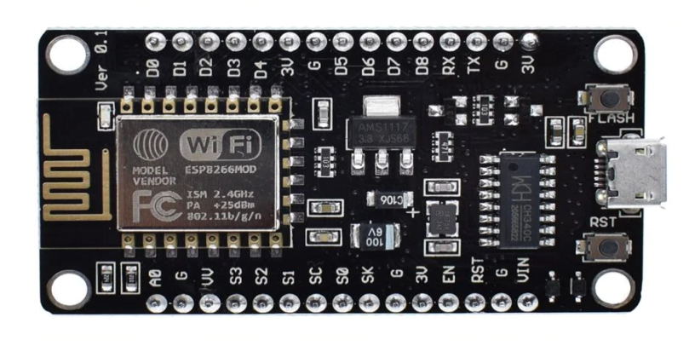

**Fig. a ESP8266 Board**

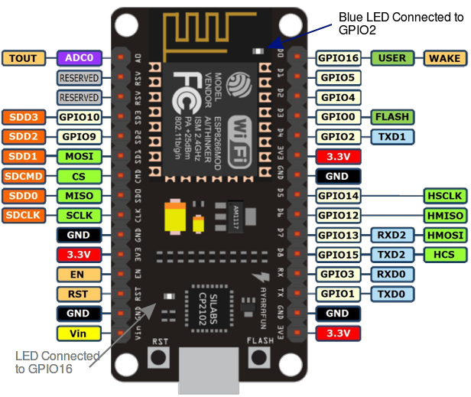

**Fig. b ESP8266 Pin Diagram**

The NodeMCU (Node MicroController Unit) is an open-source software and hardware development environment built around an inexpensive System-on-a-Chip (SoC) called the ESP8266.

The NodeMCU (Node MicroController Unit) is an open-source software and hardware development environment built around an inexpensive System-on-a-Chip (SoC) called the ESP8266. The NodeMCU is available in various package styles. Designs based on the architecture have maintained the standard 30-pin layout. Some designs use the more common narrow (0.9″) footprint, while others use a wide (1.1″) footprint. ESP8266-based boards are available from several vendors and with different breakout boards. Most of the boards differ in the number of pins made available, the amount of Flash memory for storing program and data, and the shielding on the SOC for certified boards.

Some boards also support an external uFL antenna connector as well as the built-in on-chip antenna. ESP8266 can be used as an external Wifi module, using the standard AT Command set Firmware by connecting it to any microcontroller using the serial UART, or directly serve as a Wifi-enabled microcontroller, by programming a new firmware using the provided SDK. The GPIO pins allow Analog and Digital IO, plus PWM, SPI, I2C, etc. This board has been around for almost a year now, and has been used mostly in IoT contexts, where we want to add connectivity for example to an Arduino project. A wide adoption has been facilitated by the very modest price, ranging from 2.50 to 10 USD depending on the features offered by the manufacturers.

In order to program the ESP directly you need to install a toolchain and firmware upload utility.

The [ESP8266 Wiki](https://github.com/esp8266/esp8266-wiki/wiki/Toolchain) explains the process in detail. You should use the [ESP Open SDK](https://github.com/pfalcon/esp-open-sdk) to build your toolchain. Espressif also provides an [SDK](https://github.com/esp8266/esp8266-wiki/tree/master/sdk) containing the AT Firmware and the proprietary libraries. As an alternative you might want to program the ESP using the Arduino libraries. A port of the Arduino IDE 1.6.x is available [here](https://github.com/esp8266/arduino) . The ESP8266 WiFi Module is a self-contained SOC with integrated TCP/IP protocol stack that can give any microcontroller access to your WiFi network. The ESP8266 is capable of either hosting an application or offloading all Wi-Fi networking functions from another application processor. Each ESP8266 module comes pre-programmed with an AT command set firmware, meaning, you can simply hook this up to your Arduino device and get about as much WiFi-ability as a WiFi Shield offers (and that’s just out of the box)! The ESP8266 module is an extremely cost-effective board with a huge, and ever growing, community.

**4.1.2 ARDUINO BOARD:**

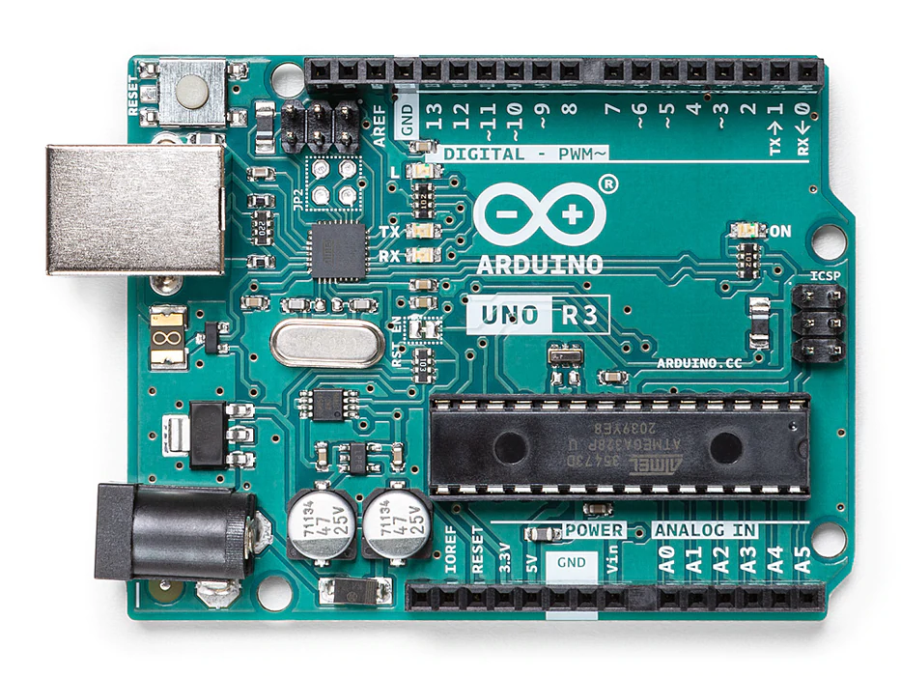

**Fig. c Arduino Uno Board**

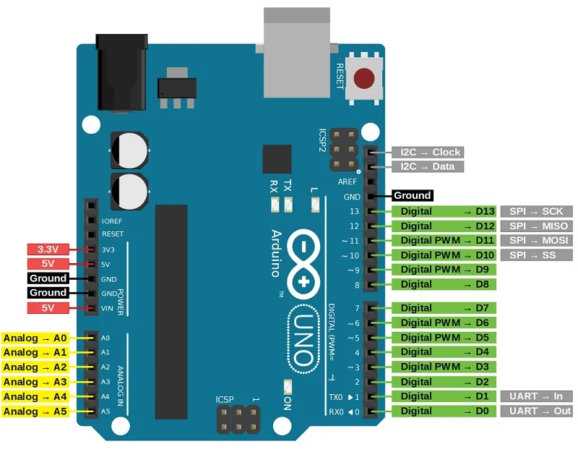

**Fig. d Arduino Pin Diagram**

Arduino is an open-source electronics platform based on easy-to-use hardware and software. [Arduino boards](https://www.arduino.cc/en/Main/Products) are able to read inputs - light on a sensor, a finger on a button, or a Twitter message - and turn it into an output - activating a motor, turning on an LED, publishing something online. You can tell your board what to do by sending a set of instructions to the microcontroller on the board.

It has 14 digital input/output pins (of which 6 can be used as PWM outputs), 6 analog inputs, a 16 MHz ceramic resonator (CSTCE16M0V53-R0), a USB connection, a power jack, an ICSP header and a reset button

It contains everything needed to support the microcontroller; simply connect it to a computer with a USB cable or power it with an AC-to-DC adapter or battery to get started. Arduino/Genuino Uno is a microcontroller board based on the ATmega328P ([datasheet](http://www.atmel.com/Images/doc8161.pdf)). It has 14 digital input/output pins (of which 6 can be used as PWM outputs), 6 analog inputs, a 16 MHz quartz crystal, a USB connection, a power jack, an ICSP header and a reset button. It contains everything needed to support the microcontroller; simply connect it to a computer with a USB cable or power it with an AC-to-DC adapter or battery to get started. You can tinker with your UNO without worrying too much about doing something wrong, worst case scenario you can replace the chip for a few dollars and start over again. "Uno" means one in Italian and was chosen to mark the release of Arduino Software (IDE) 1.0. The Uno board and version 1.0 of Arduino Software (IDE) were the reference versions of Arduino, now evolved to newer releases. The Uno board is the first in a series of USB Arduino boards, and the reference model for the Arduino platform; for an extensive list of current, past or outdated boards see the Arduino index of boards. The Arduino platform has become quite popular with people just starting out with electronics, and for good reason. Unlike most previous programmable circuit boards, the Arduino does not need a separate piece of hardware (called a programmer) in order to load new code onto the board -- you can simply use a USB cable. Additionally, the Arduino IDE uses a simplified version of C++, making it easier to learn to program. Finally, Arduino provides a standard form factor that breaks out the functions of the micro-controller into a more accessible package. The most standard and popular board used over time is **Arduino UNO**. The ATmega328 Microcontroller present on the UNO board makes it rather powerful than other boards. There are various types of Arduino boards used for different purposes and projects. The [Arduino](https://www.javatpoint.com/arduino) Boards are organised using the Arduino (IDE), which can run on various platforms. Here, IDE stands for Integrated Development Environment.

**4.1.3 MAX 30100 Pulse Oximeter sensor:**

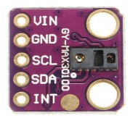

**Fig. e MAX30100 Sensor**

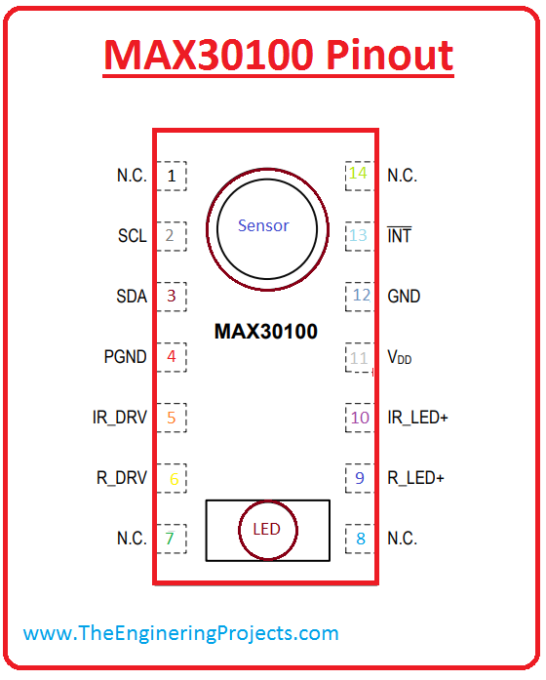

**Fig. f MAX30100 Pin Diagram**

The MAX30100 is an integrated pulse oximetry and heart-rate monitor sensor solution. It combines two LEDs, a photodetector, optimised optics, and low-noise analog signal processing to detect pulse oximetry and heart-rate signals.

The MAX30100 operates from 1.8V and 3.3V power supplies and can be powered down through software with negligible standby current, permitting the power supply to remain connected at all times.

The MAX30100 is fully configurable through software registers, and the digital output data is stored in a 16-deep FIFO within the device. The FIFO allows the MAX30100 to be connected to a microcontroller or microprocessor on a shared bus, where the data is not being read continuously from the device’s registers. The MAX30100 is an integrated pulse oximetry and heart- rate monitor sensor solution. It combines two LEDs, a photodetector, optimised optics, and low-noise analog signal processing to detect pulse oximetry and heart-rate signals.

The MAX30100 operates from 1.8V and 3.3V power sup- plies and can be powered down through software with negligible standby current, permitting the power supply to remain connected at all times.

The pulse oximetry subsystem in MAX30100 consists of ambient light cancellation (ALC), 16-bit sigma delta ADC, and proprietary discrete time filter. It has an ultra-low-power operation which makes it ideal for battery operated systems. MAX30100 operates on a supply in the range of 1.8 to 3.3V. It can be used in wearable devices, fitness assistant devices, medical monitoring devices, etc.The MAX30100 operates from 1.8V and 3.3V power supplies and can be powered down through software with negligible standby current, permitting the power supply to remain connected at all times. This **pulse sensor module for Arduino** provides the biometric data which can be used to monitor anxiety levels, remote patient monitoring or exercise routines. It has an integrated temperature sensor for calibrating the temperature dependence of pulse oximetry system. It also has a proximity detection function to reduce power consumption and visible light emission when the user’s finger is not on the sensor. It uses I2C communication to communicate with the microcontroller.

**4.1.4 LM35 Body temperature sensor:**

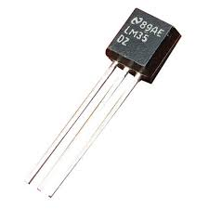

**Fig. g LM35 Body Temperature Sensor**

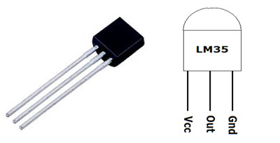

**Fig. h LM35 Pin Diagram**

LM35 is a temperature sensor that outputs an analog signal which is proportional to the instantaneous temperature. The output voltage can easily be interpreted to obtain a temperature reading in Celsius. The advantage of LM35 over thermistor is it does not require any external calibration.

The coating also protects it from self-heating. Low cost and greater accuracy make it popular among hobbyists, DIY circuit makers, and students.

LM35 can measure from -55 degrees centigrade to 150-degree centigrade. The accuracy level is very high if operated at optimal temperature and humidity levels. The conversion of the output voltage to centigrade is also easy and straightforward. The LM35 series are precision integrated-circuit temperature devices with an output voltage linearly- proportional to the Centigrade temperature. The LM35 device has an advantage over linear temperature sensors calibrated in Kelvin, as the user is not required to subtract a large constant voltage from the output to obtain convenient Centigrade scaling. The LM35 device does not require any external calibration or trimming to provide typical accuracies of ±1⁄4°C at room temperature and ±3⁄4°Cover a full −55°C to 150°C temperature range. Lower cost is assured by trimming and calibration at the water level. The low-output impedance, linear output, and precise inherent calibration of the LM35 device makes interfacing to readout or control circuitry especially easy. The device is used with single power supplies, or with plus and minus supplies. As the LM35 device draws only 60 μA from the supply, it has very low self-heating of less than 0.1°C in still air. The LM35 device is rated to operate over a −55°C to 150°C temperature range, while the LM35C device is rated for a −40°C to 110°C range (−10° with improved accuracy). The LM35-series devices are available packaged in hermetic TO transistor packages, while the LM35C, LM35CA, and LM35D devices are available in the plastic TO-92 transistor package. The LM35D device is available in an 8-lead surface-mount small-outline package and a plastic TO-220 package.

The great thing about the LM35 is that it does not require additional circuitry to function. The LM35 is an analog device. What this means is that its output voltage changes proportional with temperature. How much its voltage changes according to temperature comes down to the sensor’s sensitivity. The LM35’s sensitivity is 10mV/degree celsius. So, for example, if a voltage of 300mV appears at its output, the temperature in celsius is 30 degrees (300mV x 10mV). This temperature is provided in Centigrade (celcius). If you need to convert celsius to fahrenheit, you will need to convert this number in your code. The LM35 is a temperature sensor which is best suited for applications that measure the ambient temperature. Ambient temperature is the air temperature surrounding an object or environment where you might store equipment. So, like the heater example at the start, the LM35 would be used to measure the air temperature of the room. However, it can be used to measure body temperature as well, but direct contact will be needed. This is because the LM35 does not have the ability to measure an object’s temperature from a distance. The time it takes a sensor to react to a change in temperature is important. A temperature sensor that lags behind changes in temperature is not going to give an accurate representation as the temperature might not match the particular time stamps. Also, you might require it to give instantaneous updates. So, the lower the response time the better. The LM35 has a relatively fast response time if it is already at ambient temperature and the change in temperature is gradual. However, an abrupt change in temperature could increase the response time of the LM35 up to 2 minutes. When it comes to body temperature, your main concern should be the accuracy of temperature reading. So, the response time of the LM35 shouldn’t be much of an issue. While you can use a LM35 to measure body temperature, a question to ponder is whether it is the best option. A couple of downsides of using the LM35 to measure body temperature are its response time, and if it is measuring an object’s temperature (like the body) it will need to come in contact with it. A non-contact temperature sensor (that uses infra-red) would be more ideal for measuring body temperature.

**4.1.5 DHT11 Humidity and Temperature sensor:**

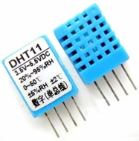

**Fig. I DHT11 Sensor**

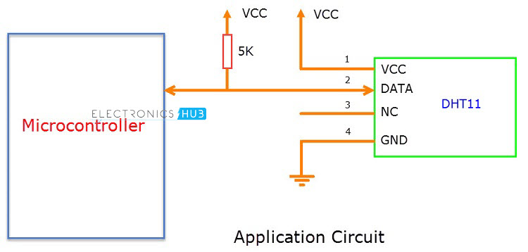

**Fig. j DHT11 Pin Diagram**

DHT11 is a low-cost digital sensor for sensing temperature and humidity. This sensor can be easily interfaced with any micro-controller such as Arduino, Raspberry Pi etc to measure humidity and temperature instantaneously.

The humidity sensing [capacitor](https://www.elprocus.com/construction-of-capacitor-with-working/) has two electrodes with a moisture holding substrate as a dielectric between them. Change in the capacitance value occurs with the change in humidity levels. The IC measure processes this changed resistance values and changes them into digital form.

For measuring temperature this sensor uses a Negative Temperature coefficient thermistor, which causes a decrease in its resistance value with increase in temperature.The DHT11 is a basic, ultra-low-cost digital temperature and humidity sensor. It uses a capacitive humidity sensor and a thermistor to measure the surrounding air, and spits out a digital signal on the data pin (no analog input pins needed). It’s fairly simple to use, but requires careful timing to grab data. You can get new data from it once every 2 seconds, so when using the library from Adafruit, sensor readings can be up to 2 seconds old. Comes with a 4.7K or 10K resistor, which you will want to use as a pullup from the data pin to VCC. The **DHT11 sensor** can either be purchased as a sensor or as a module. Either way, the performance of the sensor is the same. The sensor will come as a 4-pin package out of which only three pins will be used whereas the module will come with three pins as shown above. The only difference between the sensor and module is that the module will have a filtering capacitor and pull-up resistor inbuilt, and for the sensor, you have to use them externally if required.

The **DHT11** is a commonly used **Temperature and humidity sensor.** The sensor comes with a dedicated NTC to measure temperature and an 8-bit microcontroller to output the values of temperature and humidity as serial data. The sensor is also factory calibrated and hence easy to interface with other microcontrollers. The sensor can measure temperature from 0°C to 50°C and humidity from 20% to 90% with an accuracy of ±1°C and ±1%. So if you are looking to measure in this range then this sensor might be the right choice for you. Each DHT11 element is strictly calibrated in the laboratory that is extremely accurate on humidity calibration. The calibration coefficients are stored as programmes in the OTP memory, which are used by the sensor’s internal signal detecting process. The single-wire serial interface makes system integration quick and easy. Its small size, low power consumption and up-to-20 metre signal transmission make it the best choice for various applications, including those most demanding ones. The component is a 4-pin single row pin package. It is convenient to connect and special packages can be provided according to users’ request.

**4.1.6 LM358 comparator-saline indication:**

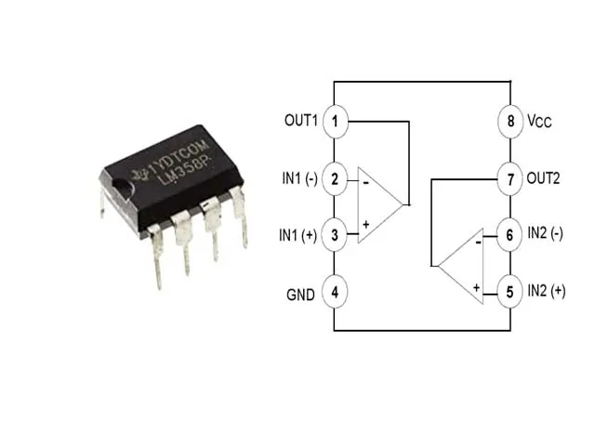

**Fig. k LM358 Comparator**

The main circuit of the saline level gauge is composed of 4 LM359 comparators, This kind of integrated circuit has the characteristics of easy purchase, low price, single power supply operation, and wide differential range.

The voltage signal measurement consists of a reed switch and a voltage divider resistor. The ring magnets suspended in the water are in different positions. Due to the principle of electromagnetic induction, not only the corresponding dry reed switch normally open contacts are closed, but also the corresponding voltage divider resistor is connected. Therefore, the circuit will pick up different voltage signals.

**4.1.7 Breadboard:**

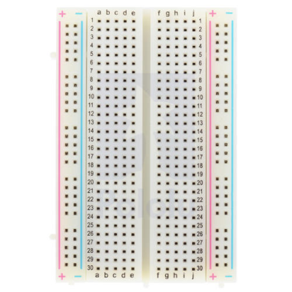

**Fig. l Breadboard**

A thin plastic board used to hold electronic components (transistors, resistors, chips, etc.) that are wired together. Used to develop prototypes of electronic circuits, breadboards can be reused for future jobs. They can be used to create one-of-a-kind systems but rarely become commercial products.

**4.1.8 Jumper wires:**

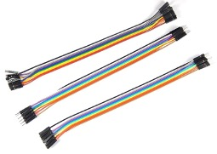

**Fig. m Jumper Wires**

Jumper wires are simply wiring that have connector pins at each end, allowing them to be used to connect two points to each other without soldering. Jumper wires are typically used with breadboards and other prototyping tools in order to make it easy to change a circuit as needed.

**4.1.9 Buzzer:**

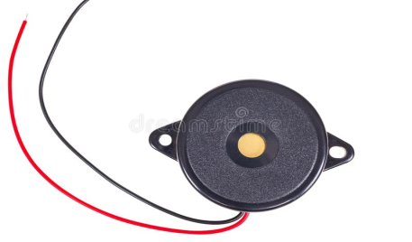

**Fig. n Buzzer**

The [buzzer](https://www.quisure.com/blog/faq/what-is-a-buzzer) is a sounding device that can convert audio signals into sound signals. It is usually powered by DC voltage. It is widely used in alarms, computers, printers and other electronic products as sound devices

**4.1.10. NodeMCU:**

NodeMCU is an open-source firmware for which open-source prototyping board designs are available. The name "NodeMCU" combines "node" and "MCU" (micro controller unit). The term "NodeMCU" strictly speaking refers to the firmware rather than the associated development kits. Both the firmware and prototyping board designs are open source. The firmware uses the Lua scripting language. The firmware is based on the eLua project, and built on the Espress if Non-OS SDK for ESP8266.By exploring functionality with ESP8266 chip, NodeMCU firmware comes with ESP8266 Development board/kit i.e.NodeMCU Development board. It uses many open-source projects. Due to resource constraints, users need to select the modules relevant for their project and build a firmware tailored to their needs. Support for the 32-bit ESP32 has also been implemented. The NodeMCU is a single board microcontroller type.

The prototyping hardware typically used is a circuit board functioning as a dual in-line package (DIP) which integrates a USB controller with a smaller surface-mounted board containing the MCU and antenna. The choice of the DIP format allows for easy prototyping on breadboards. The design was initially based on the ESP-12 module of the ESP8266, which is a WiFi SoC integrated with a TensilicaXtensa LX106 core, widely used in IoT applications. NodeMCU Development board is featured with wifi capability, analog pin, digital pins, and serial communication protocols. To get started with using NodeMCU for IoT applications first we need to know about how to write/download NodeMCU firmware in NodeMCU Development Boards. And before that where this NodeMCU firmware will get as per our requirement. There are online NodeMCU custom builds available using which we can easily get our custom NodeMCU firmware as per our requirement.

Well, there is a programming language difference we can say while developing an application for NodeMCU using ESPlorer IDE and Arduino IDE. We need to code in C\C++ programming language if we are using Arduino IDE for developing NodeMCU applications and Lua language if we are using ESPlorer IDE. Basically, NodeMCU is Lua Interpreter, so it can understand Lua script easily. When we write Lua scripts for NodeMCU and send/upload it to NodeMCU, then they will get executed sequentially. It will not build a binary firmware file of code for NodeMCU to write. It will send Lua script as it is to NodeMCU to get executed. In Arduino IDE when we write and compile code, the ESP8266 toolchain in the background creates a binary firmware file of code we wrote. And when we upload it to NodeMCU then it will flash all NodeMCU firmware with newly generated binary firmware code. In fact, it writes the complete firmware. That’s the reason why NodeMCU does not accept further Lua scripts/code after it is getting flashed by Arduino IDE. After getting flashed by Arduino sketch/code it will be no more Lua interpreter and we got an error if we try to upload Lua scripts. To start again with Lua script, we need to flash it with NodeMCU firmware. Since Arduino IDE compiles and uploads complete firmware, it takes more time than ESPlorer IDE.

**4.2 Software Requirements:**

* Arduino IDE
* Blynk application

**4.2.1 Arduino IDE (Integrated development environment):**

* Arduino IDE is an open-source software, designed by Arduino.cc and mainly used for writing, compiling & uploading code to almost all Arduino Modules.
* It is an official Arduino software, making code compilation so easy that even a common person with no prior technical knowledge can get their feet wet with the learning process.
* It is available for all operating systems i.e., MAC, Windows, Linux and runs on the Java Platform that comes with inbuilt functions and commands that play a vital role in debugging, editing and compiling the code.
* A range of Arduino modules available including Arduino Uno, Arduino Mega, Arduino Leonardo, [Arduino Micro](https://www.theengineeringprojects.com/2018/09/introduction-to-arduino-micro.html) and many more.
* Each of them contains a microcontroller on the board that is actually programmed and accepts the information in the form of code.
* The main code, also known as a sketch, created on the IDE platform will ultimately generate a Hex File which is then transferred and uploaded in the controller on the board.
* The IDE environment mainly contains two basic parts: Editor and Compiler where former is used for writing the required code and later is used for compiling and uploading the code into the given Arduino Module.
* This environment supports both C and C++ languages

**4.2.2 Blynk:**

Blynk was designed for the functioning of IOT devices. It can control hardware remotely, it can display sensor data, it can store data and visualise it. Blynk is a new platform that allows you to quickly build interfaces for controlling and monitoring hardware projects from iOS and Android devices. After downloading the Blynk app, we can create a project dashboard and arrange buttons, sliders, graphs, and other widgets onto the screen. In the current project we will be connecting the ESP32 web server to the blynk’s interface and control the health monitor system through the app which will display active and live measurements. On the plus side, through this particular application we can acquire a dataset of all the past records of the usage of the device.

There are three major components in the platform:

* Blynk App - allows you to create amazing interfaces for your projects using various widgets we provide.
* Blynk Server - responsible for all the communications between the smartphone and hardware. You can use our Blynk Cloud or run your
* [private Blynk server](https://docs.blynk.cc/#blynk-server) locally. It’s open-source, could easily handle thousands of devices and can even be launched on a Raspberry Pi.
* Blynk Libraries - for all the popular hardware platforms - enable communication with the server and process all the incoming and outcoming commands.

Blynk is a new platform that allows you to quickly build interfaces for controlling and monitoring your hardware projects from your iOS and Android device. After downloading the Blynk app, you can create a project dashboard and arrange buttons, sliders, graphs, and other widgets onto the screen. Using the widgets, you can turn pins on and off or display data from sensors. Whatever your project is, there are likely hundreds of tutorials that make the hardware part pretty easy, but building the software interface is still difficult. With Blynk, though, the software side is even easier than the hardware. Blynk is perfect for interfacing with simple projects like monitoring the temperature of your fish tank or turning lights on and off remotely. Personally, I’m using it to control RGB LED strips in my living room.

Blynk started as a [Kickstarter campaign](https://www.kickstarter.com/projects/167134865/blynk-build-an-app-for-your-arduino-project-in-5-m), raising just over $49k. The platform went live on May 22, and has been continuously updated since. In fact, new widgets have just been added to the app for Twitter, push, and email integration. Currently, Blynk supports most Arduino boards, Raspberry Pi models, the ESP8266, Particle Core, and a handful of other common microcontrollers and single-board computers, and more are being added over time. Arduino Wi-Fi and Ethernet shields are supported, though you can also control devices plugged into a computer’s USB port as well. One of my favourite aspects of Blynk is that you can create a local Blynk server, allowing you to keep everything within your own home network. This is useful if you’re setting up a network in a remote location, or if you’re concerned about your traffic going through other machines in [the cloud](https://fsfe.org/contribute/promopics/thereisnocloud_thumb.png). While there are other platforms for controlling hardware over the internet (Particle, ThingSpeak, Temboo, IFTTT), Blynk is one of the most user-friendly I’ve seen yet, and it’s also free and open-source under an [MIT licence](http://opensource.org/licenses/MIT). For more information, and to download the Blynk library for your next project, check out [their website](http://www.blynk.cc/).

**5. PROCEDURE**

* Install arduino Software/libraries
* Compile the Code
* Upload the code into Iot device
* Apply each sensor consequently
* Acquire readings in Blynk

**5.1 Detailed Procedure:**

* To execute the code, arduino needs to be first installed in the working console. Since ESP8266 is used in the project, the microcontroller needs to be updated into the arduino IDE by opening file>preference, under additional boards URL replace with:

<http://arduino.esp8266.com/stable/package_esp8266com_index.json>,

* On updating ESP8266 onto the arduino IDE, install other necessary libraries depending on the sensors being used. For instance, In the current project, DHT11 sensor is used to monitor room temperature and humidity levels. To install the library open tools>boards manager>DHT11. Install the DHT11 library. SImilarly, libraries related to pulse oximeter, body temperature and saline detection are installed into the arduino IDE.
* Upon installing all the necessary libraries, execute the code. Debug if any error else upload the code into the Iot device.
* Apply each sensor consequently to receive readings on the blynk app which is a mobile app connected to the web server. Alternatively, on entering the IP address in the web browser in any device, readings are displayed in plain text.
* Blynk app consists of an admin and user dashboard, where the admin can maintain a record of readings.
* In Case of abnormal readings, a buzzer is rung and a warning message is popped in the app.

**5.2 System analysis:**

The designed IOT based healthcare monitoring model is a combination of hardware and software components. The hardware components include the ESP8266 development board, Arduino uno board and the software components include the blynk application. Through this device a study can be made that we can operate several functions using low power supply and not very complex programming is required to design the model which shows the flexibility and reliability of the IOT device. Multiple sensors have been used in developing this kit, even on adding or removing any sensor there is no requirement foraltering the entire model which shows the simplicity of the approach. Blynk application can be accessed from laptop or mobile or from any component that has the access of Internet and CPU, just the application needed to be downloaded. It is a very reliable and easy user interface application, as the user can design his or her own dashboard. There is a buzzer attached to the ESP8266 development board which starts beeping when the readings exceed abnormally. Simultaneously, notifications and pop-up messages are directly sent to the concern authorities which include family members of the patient.

**5.3 Design:**

The proposed model design is displayed, along with the block diagram and flowchart of the designed IOT model. Fig. a describes the block diagram of the model and Fig. b describes the flowchart of the model.

**5.3.1 Block Diagram:**

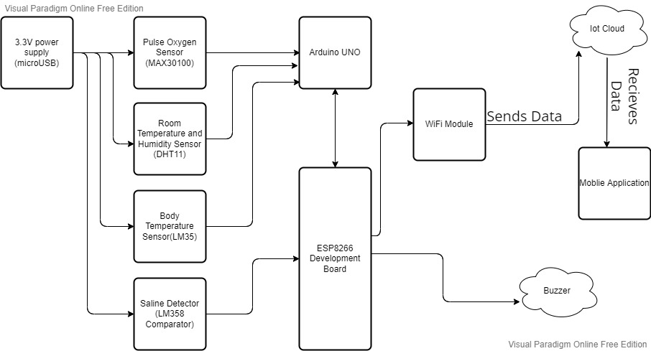

**Fig. o Project Block Diagram**

The above block diagram (Fig. o) depicts the working of an IoT based HealthCare monitoring System. The device is first supplied with 3.3 V power input into the micro-USB connection or through the adaptor connection given by the arduino kit. The power must be maintained at 3.3 V as exceeding these units can burn the microcontrollers thereby impacting the output. Each sensor and microcontroller run on this power supply through a distributed current supply. On applying each sensor consequently, they are activated and begin generating outputs by transmitting function calls with the microcontrollers like the ESP8266 and arduino uno. AS we can see only the saline detector sensor also called LM35 comparator is connected to ESP8266, this is done to prevent looping of function calls with the other sensors. While other sensors like pulse oxygen sensor, room temperature and humidity sensor and body sensor are connected to the arduino uno microcontroller. The two microcontrollers are connected by a jumper wire in the TX and RX ports for transmission purpose. On receiving function calls through sensor’s microcontrollers fetch the necessary data and transmit to a wifi module which is built in. The wifi module then sends data to the IoT cloud for storage and retrieval purposes. If the destination is a mobile application, then the readings are directly displayed on the mobile monitor. There is a buzzer attached to the ESP8266 development board to beep whenever the readings exceed abnormally.

**5.3.2 FLOWCHART:**

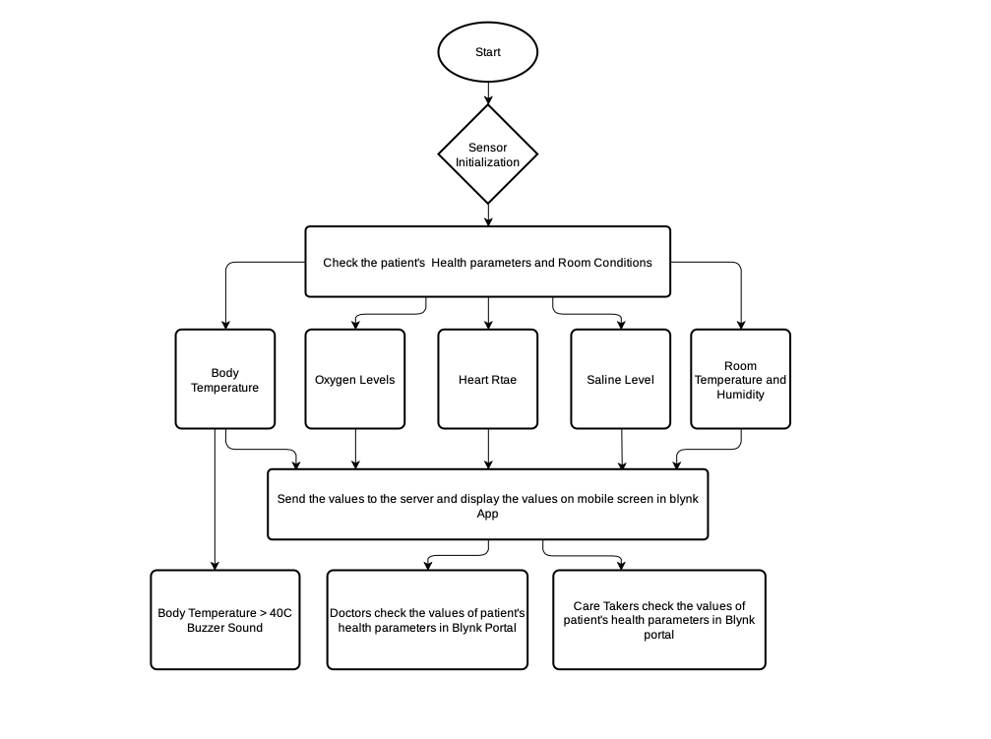

**Fig. p project Flow Chart**

The above flow chart (Fig. p) shows the flowchart of the steps performed in the whole process. It shows the order of the workflow and steps in the sequential order, including the initialization, setting up of protocols successfully, reading sensor values accurately, sending measure values to display monitor and cloud server to store sensor data.

**5.3.3 Circuit Diagram:**

The system is implemented using the combination of hardware components. All the hardware components are assembled in the implementation phase. The circuit diagram of the developed system is demonstrated in Fig. q. All the sensors are connected with ESP8266 using physical pins. ESP8266 is used as a processing device as it has a built-in Wi-Fi module. For all sensors, the *V*cc and GND are connected with the *V*cc and GND pin of ESP8266. In the case of a heart beat sensor, the signal pin is connected with the D26 pin of ESP8266. The data pin of LM35 is mapped with the D35 pin of the microcontroller (ESP8266). These are the case with a specific patient. For room condition monitoring, the data pin of DHT11 is linked with ESP8266’s D14 pin. In the implementation, DHT11 is only considered for room humidity measurement. The digital outputs of MQ-9 and MQ-135 are connected with D27 and D34 of ESP8266, respectively, for the measurement of toxic gases in room environments.

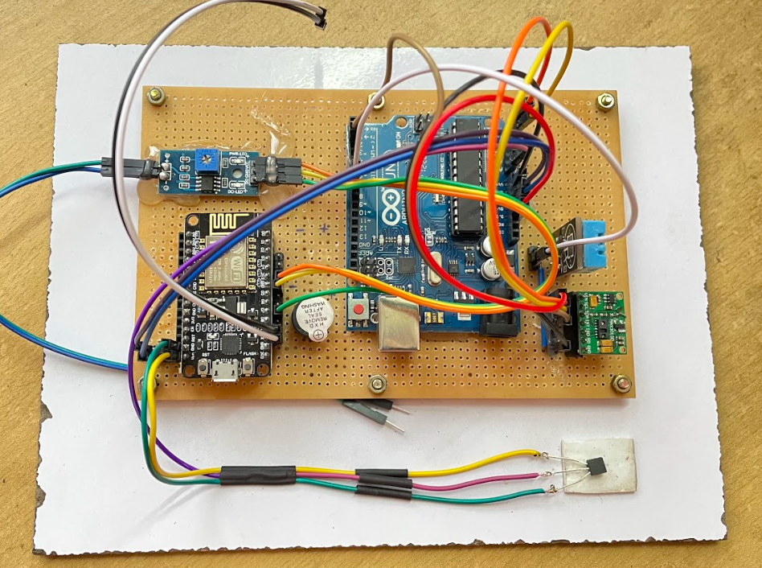

**Fig. q Project Circuit Diagram**

**6. CODING**

**Arduino_spo2 file:**

#include <Wire.h>

#include "MAX30100_PulseOximeter.h"

#include <DHT.h>

#define REPORTING_PERIOD_MS 1000

#define DHTPIN 7

#define DHTTYPE DHT11

float temp;

PulseOximeter pox;

DHT dht(DHTPIN, DHTTYPE);

uint32_t tsLastReport = 0;

int sdata1 = 0; // sensor1 data

int sdata2 = 0; // sensor2 data

int sdata3 = 0; // sensor3 data

int sdata4 = 0; // sensor4 data

int sdata5 = 0; // sensor5 data

String cdata; // complete data, consisting of sensors values

void onBeatDetected()

{

//Serial.println("Beat!");

}

void setup()

{

Serial.begin(9600);

Serial.print("Initializing pulse oximeter..");

if (!pox.begin()) {

Serial.println("FAILED");

for(;;);

} else {

Serial.println("SUCCESS");

}

pox.setOnBeatDetectedCallback(onBeatDetected);

dht.begin();

}

void loop()

{

float h = dht.readHumidity();

float t = dht.readTemperature();

temp = analogRead(A0);

temp = temp*(5/1023.0)*100;

pox.update();

if (millis() - tsLastReport> REPORTING_PERIOD_MS)

{

cdata = cdata + sdata1+","+sdata2+","+sdata3+","+sdata4+","+sdata5; // comma will be used a delimeter

Serial.println(cdata);

cdata = "";

//Serial.print("Heart rate:");

//Serial.print(pox.getHeartRate());

//Serial.print("bpm / SpO2:");

//Serial.print(pox.getSpO2());

//Serial.println("%");

sdata1 = pox.getHeartRate();

sdata2 = pox.getSpO2();

//Serial.print("Humidity :");

//Serial.println(h);

sdata3 = h;

//Serial.print("Temperature");

//Serial.println(t);

sdata4 = t;

//Serial.print("Temp: ");

//Serial.println(temp);

sdata5 = temp;

//Serial.println("*********************************");

//Serial.println();

tsLastReport = millis();

}

}

**spo2_patient_nodeMCU file :**

#define BLYNK_TEMPLATE_ID "TMPLD56vrHpk"

#define BLYNK_DEVICE_NAME "Health Care"

#define BLYNK_AUTH_TOKEN "VWcRGXiN3QAqiD6Mrd1HJ8l1uHe4NQpT"

#define BLYNK_PRINT Serial

#include <ESP8266WiFi.h>

#include <BlynkSimpleEsp8266.h>

#include <SimpleTimer.h>

char auth[] = BLYNK_AUTH_TOKEN;

char ssid[] = "Project"; // Enter your Wifi Username

char pass[] = "123@Apple"; // Enter your Wifi password

SimpleTimer timer;

int Selain = D7;

int Buzzer = D6;

String myString; // complete message from arduino, which consistors of snesors data

char rdata; // received charactors

int firstVal,secondVal,thirdVal,fourthVal,fifthVal; // sensors

void myTimerEvent()

{

Blynk.virtualWrite(V1, millis() / 1000);

}

void setup()

{

Serial.begin(9600);

pinMode(Selain, INPUT);

pinMode(Buzzer, OUTPUT);

digitalWrite(Buzzer,LOW);

Blynk.begin(auth, ssid, pass);

timer.setInterval(1000L,sensorvalue1);

timer.setInterval(1000L,sensorvalue2);

timer.setInterval(1000L,sensorvalue3);

timer.setInterval(1000L,sensorvalue4);

timer.setInterval(1000L,sensorvalue5);

timer.setInterval(1000L,sensorvalue6);

}

void loop()

{

if (Serial.available() == 0 )

{

Blynk.run();

timer.run(); // Initiates BlynkTimer

}

if (Serial.available() >0 )

{

rdata = Serial.read();

myString = myString+ rdata;

// Serial.print(rdata);

if( rdata == '\n')

{

// Serial.println(myString);

// Serial.println("fahad");

// new code

String l = getValue(myString, ',', 0);

String m = getValue(myString, ',', 1);

String n = getValue(myString, ',', 2);

String o = getValue(myString, ',', 3);

String p = getValue(myString, ',', 4);

firstVal = l.toInt();

secondVal = m.toInt();

thirdVal = n.toInt();

fourthVal = o.toInt();

fifthVal = p.toInt();

myString = "";

}

}

}

void sensorvalue6()

{

if(digitalRead(Selain) == LOW)

{

Blynk.virtualWrite(V10, 0);

delay(500);

}

else

{

Blynk.virtualWrite(V10, 255);

delay(500);

}

}

void sensorvalue1()

{

int sdata = firstVal;

// You can send any value at any time.

// Please don't send more that 10 values per second.

Blynk.virtualWrite(V2, sdata);

}

void sensorvalue2()

{

int sdata = secondVal;

// You can send any value at any time.

// Please don't send more that 10 values per second.

Blynk.virtualWrite(V3, sdata);

}

void sensorvalue3()

{

int sdata = thirdVal;

// You can send any value at any time.

// Please don't send more that 10 values per second.

Blynk.virtualWrite(V4, sdata);

}

void sensorvalue4()

{

int sdata = fourthVal;

// You can send any value at any time.

// Please don't send more that 10 values per second.

Blynk.virtualWrite(V5, sdata);

}

void sensorvalue5()

{

int te = fifthVal;

// You can send any value at any time.

// Please don't send more that 10 values per second.

Blynk.virtualWrite(V6, te);

if (te> 50)

{

digitalWrite(Buzzer,HIGH);

delay(500);

}

else

{

digitalWrite(Buzzer,LOW);

delay(500);

}

}

String getValue(String data, char separator, int index)

{

int found = 0;

int strIndex[] = { 0, -1 };

int maxIndex = data.length() - 1;

for (int i = 0; i<= maxIndex&& found <= index; i++) {

if (data.charAt(i) == separator || i == maxIndex) {

found++;

strIndex[0] = strIndex[1] + 1;

strIndex[1] = (i == maxIndex) ? i+1 : i;

}

}

return found >index ?data.substring(strIndex[0], strIndex[1]) : "";

}

**7. CASE STUDIES**

**7.1 Case study 1: Proper monitoring of patients admitted in the hospital -**

With the severity of the pandemic the past few months, many patients could not be monitored on time as the staff were less and there was lack of equipment. The health care monitor system will help in monitoring the patients in real time by sending all readings to the hospital staff through the web server. With the inclusion of a warning buzzer in case of abnormal readings, quick treatment can be given to the patients. The benefits of using an automated IoT device in the health sector is that it is versatile in nature and can be modified depending upon the severity and health condition of the patient. For Instance, a person suffering from diabetes and heart issues can have a device modified to monitor all such parameters related to sugar and heart rate by using various sensors. The benefit of using an ESP32 development board in the project is that it has over 48 pins and can be connected to the wifi. Considering these features, we can add many sensors and monitor readings from a distance.

**7.2 Case study 2: Monitoring of old age bedridden patients -**

There persists a common problem in monitoring the health conditions of old aged people as the nurses appointed may not be reliable and patient enough to take care or it might be difficult to get a doctor to check every once in a while, if the person is bedridden at home. To battle this inconvenience, an automated health monitor system can be used to check for regular vitals and send them to the concerned person. In addition, with the help of saline detector the caretaker can be intimated whenever the saline is empty in the saline bag. There are some serious consequences if the saline bag is left unattended as it will pass dry air into the blood vessels causing the person to suffer from paralysis. With the presence of a database, all the past recordings can be maintained to check the progress of the patient. In case of an emergency, immediate warning signals are sent to the hospital and family members.

As a person enters old age, it becomes increasingly vital for them to undergo standard medical health checkups. Since it may be time-consuming and difficult for most people to get regular health checkup appointments, IoT-based arrangements can be beneficial to individuals for routine health checkups [4, 5]. IoT technology has developed into an imperative innovation with applications in numerous areas. Specifically, it refers to any system of physical devices that obtain and exchange information over wireless systems without human mediation.

**8. TEST CASES**

**Minimum values obtained:**

| **Bpm**  <65 | **SpO2**  <90 | **Humidity**  34 |
| --- | --- | --- |
| **Room Temperature**  <15 | **Body Temperature**  <37 | **Saline Detection**  Null |

**Table. 1 minimum value test case**

**Observation:** The obtained values from table.1 are deemed to be minimum which will be notified in the Blynk dashboard. Such occurrences of values are meant to be diagnosed closely by a Physician or any Health care worker, a pop-up message will be sent to the concerned authorities to treat the patient accordingly. The readings obtained will be saved in the admin’s database in case of retrieval of data for diagnosis.

**Moderate Values Obtained:**

| **Bpm**  74 | **SpO2**  97 | **Humidity**  60 |
| --- | --- | --- |
| **Room Temperature**  25 | **Body Temperature**  37 | **Saline Detection**  Red |

**Table. 2 moderate value test case**

**Observation:** The obtained values from Table. 2 are taken under standard values displaying normal health conditions of the user. Such occurrence of values does not require any attention by concerned authorities. The values deem to be normal and the patient is healthy according to a general checkup.

**Maximum values obtained:**

| **Bpm**  >120 | **SpO2**  >100 | **Humidity**  >150 |
| --- | --- | --- |
| **Room Temperature**  >45 | **Body Temperature**  >37 | **Saline Detection**  Red |

**Table. 3 Maximum value test case**

**Observation:** The values obtained from the above Table. 3 deems to be very abnormal. Any occurrence of such values requires immediate attention. On receiving such abnormal results A buzzer placed in the model will start beeping and simultaneously transmit emergency notifications to the concerned personnel. According to a basic diagnosis an assumption can be made that the user is undergoing a serious health condition which requires immediate care.

**9. EXPERIMENTAL RESULTS**

| **Bpm**  74 | **SpO2**  97 | **Humidity**  54 |
| --- | --- | --- |
| **Room Temperature**  34 | **Body Temperature**  37 | **Saline Detection**  Null/Red |

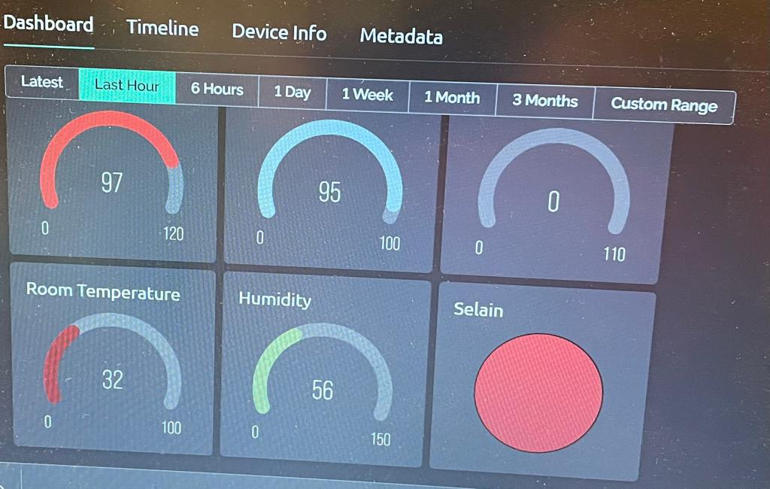**Table. 4 Experimental results**

**Fig. r Output in Blynk**

Table. 4 represents the recorded values of the experiment done on a healthy person.The above picture (fig. r)represents the blynk dashboard that contain the values of heartbeat per minute, blood oxygen levels,Room humidity,Room temperature and body temperature of the person on whom the experiment is done.A perfectly healthy person has the moderate values with Bpm-74,Blood oxygen level-97,Room Humidity-54,Room Temperature-34,Body Temperature-34,Saline Detection-Null/Red.

**10. CONCLUSION AND FUTURE SCOPE**

Through the project a conclusion can be derived that IOT devices are very useful and effective in the health care sector. Seeing how portable and cost effective the devices are, a huge number of users can benefit from the effective results from the IOT devices. Making the device automated saves time and provides accurate readings at ease.

This project proves that the device is very versatile, that is any number of sensors can be added anytime despite updating any software. Depending on the illness of the patients the device can be modified for better treatment.

**Scope:**

We can add a GPS module in IOT patient monitoring using the Arduino Uno and the WiFi module project. This GPS module will find out the position or the location of the patient using the longitude and latitude received. Then it will send this location to the cloud that is the IOT using the Wi-Fi module. Then doctors can find out the position of the patient in case they have to take some preventive action.

**BIBLIOGRAPHY**

          Shwetha Singh. Psychoinformatics

      Deepthi Pandey, Raghu Prasad.  “Psychoinformatics: a theoretical approach on information science and              psychology”

Lei Ru, Bin Zhang, Jing Duan, Guo Ru, Ashutosh Sharma, Gaurav Dhiman, Gurjot Singh Gaba, Emad Sami Jaha, and Mehedi Masud.  “A Detailed Research on Human Health Monitoring System Based on the Internet of Things”.

Nor Shahanim Mohamad Hadis,, Muhammad NazriAmirnazarullah , Muhammad Mahdi Jafri and Samihah Abdullah. IoT Based Patient Monitoring System using Sensors to Detect, Analyse and Monitor Two Primary Vital Signs

[NarongritSenajit](https://pubmed.ncbi.nlm.nih.gov/?term=Senajit+N&cauthor_id=34866803) , [PiyaPrasongchan](https://pubmed.ncbi.nlm.nih.gov/?term=Prasongchan+P&cauthor_id=34866803). Contactless Body Temperature Monitoring of In-Patient Department (IPD) Using 2.4 GHz Microwave Frequency via the Internet of Things (IoT) Network [Wasana Boonsong](https://pubmed.ncbi.nlm.nih.gov/?term=Boonsong+W&cauthor_id=34866803).

**APPENDIX**



**ESP8266 Pin Diagram**



**Arduino Uno Pin Diagram**



**MAX30100 Sensor Pin Diagram**



**DHT11 Pin Diagram**

**RESEARCH PAPER**

